

Excel Assignment - 18

1. What are comments and what is the importance if commenting in any code?

Commenting involves placing Human Readable Descriptions inside of computer programs detailing what the Code is doing. Proper use of commenting can make code maintenance much easier, as well as helping make finding bugs faster. Further, commenting is very important when writing functions that other people will use.

It saves time hence is the only resource that is finite and you do not want to be stuck in front of a computer screen trying to find a solution to why this particular set of codes is not able to compile.

It provides other users ease of understanding the code.

It provider other ushers ease of reading the code.

It provide info of the context and source of the code

In some cases, the time saved could be weeks and months of precious development allowance. As with many similar instances that any seasoned programmer can tell you, it is a daunting experience to dig through a code without…

1. What is Call Statement and when do you use this statement?

Transfers control to a sub-procedure,function procedure, or Dynamic link Labrrary (DDL) procedure. The **CALL statement transfers control from one object program to another within the run unit**. The program containing the CALL statement is the calling program.

We use call statement when we have a condition,

If Formula Excel

Use the IF function, one of the logical functions, to return one value if a condition is true and another value if it's false. For example: =IF(A2>B2,"Over Budget","OK") =IF(A2=B2,B4-A4,"")

1. How do you compile a code in VBA? What are some of the problems that you might face when you don’t compile a code?

You can compile your VBA code by clicking Debug Menu → Compile VBA Project. A compile error for a missing “End if” part of an IF statement. Every individual line in the code is correct, but together, they don't represent a complete IF statement.

When writing VBA code, you may have the below errors.

* Syntax Errors. While writing VBA code you need to follow a particular Syntax and when you skip it or don't write it in the way it should be you can face SYNTAX error (also called Language error).
* Compile Errors. ...
* Runtime Errors. ...
* Logical Error.
* **The VBA code in one of your workbooks becomes corrupt**
* **Problem of add in which causes the excel to crash.**

1. What are hot keys in VBA? How can you create your own hot keys?

Hot keys are shortcuts keys used to create VBA codes.

How to create hot keys keyboard shortcut.

* On the Developer tab, in the Code group, click Macros.
* In the Macro dialog box, click Options.
* The Macro Options dialog box will appear.
* In the Shortcut key box, type any uppercase or lowercase letter that you want to use for the shortcut, and then click OK to save the changes

1. Create a macro and shortcut key to find the square root of the following numbers 665, 89, 72, 86, 48, 32, 569, 7521

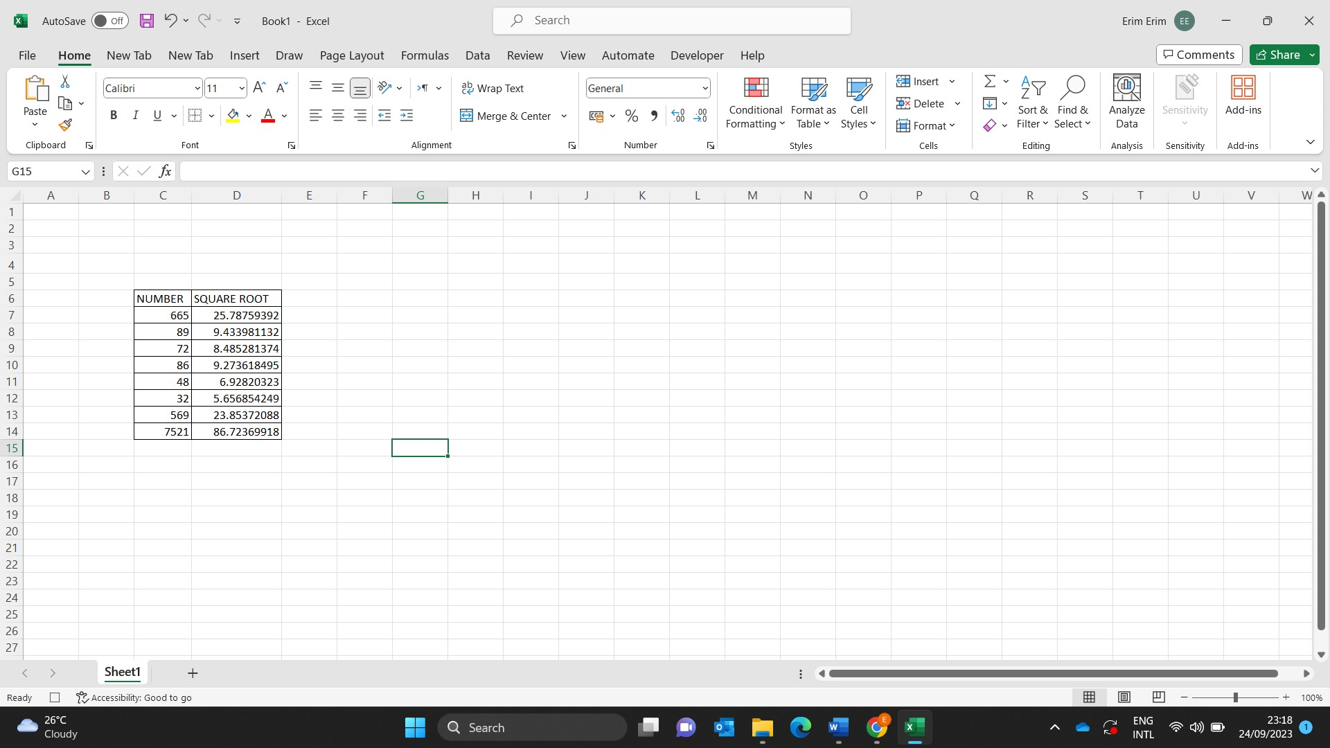

6.What are the short cut keys to run the code

1. Run the code

F5

1. Step into the code

**F8**

1. Step out of code

Ctrl +Shift+F8

1. Reset the code

Alt+Q